Jˆ_ **Project Information**

**Assignment-2**

Team ID: LTVIP2025TMID51035

Team Leader: Nanadyala sai Koushik

INSTITUTION: Rise krishna sai prakasam group of institution

Project Title: Measuring the Pulse of Prosperity: An Index of Economic Freedom Analysis

]¡# **Visualization Screenshots**

# ⬛¹ Donut Chart – Branch-wise Sales Contribution Caption: this is made by me as gif type…

This donut chart displays the total sales contribution from each branch (A, B, C). The center highlights the overall sales volume while the segments show the proportional share by branch.

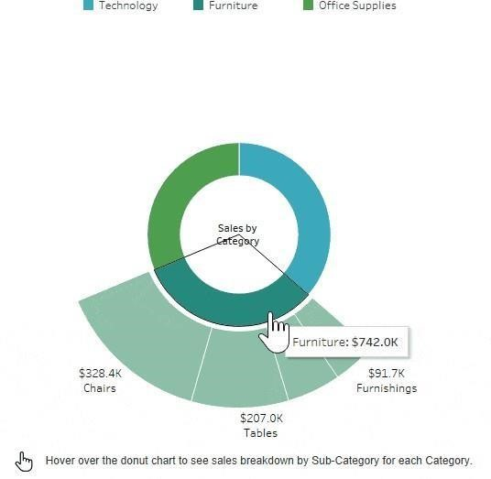

# ⬛2 Area Chart – Monthly Sales Trend

**Caption:**

This area chart visualizes the total sales over the three months (January to March 2019). It uses color shading to show branch-level contributi

on across time.

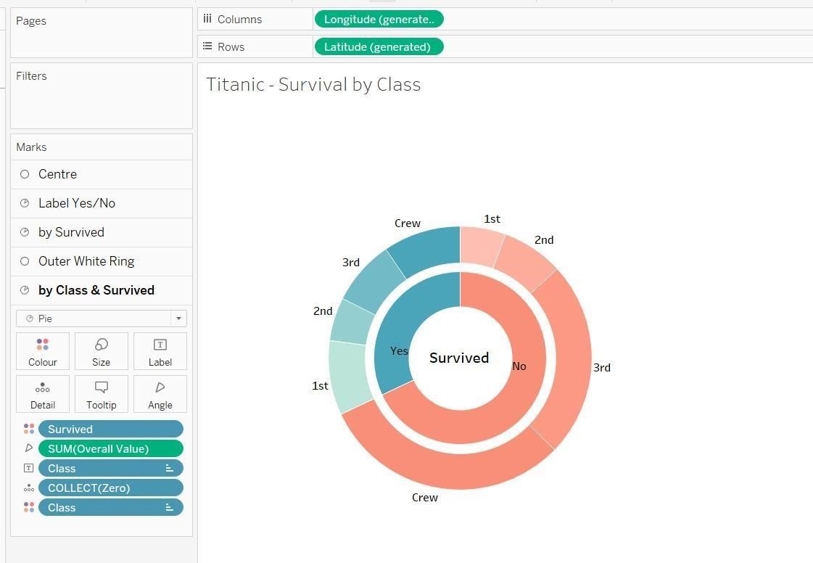

# ⬛3 Text Table – Product Line Sales Summary Caption: converted into gif by me…

This text table provides a detailed breakdown of sales, quantity sold, gross income, and average customer rating per product line and customer type.



.

# ⬛f Word Cloud – Most Purchased Product Lines

**Caption:**

This word cloud illustrates the popularity of different product lines based on the number of items purchased. Font size reflects quantity sold.

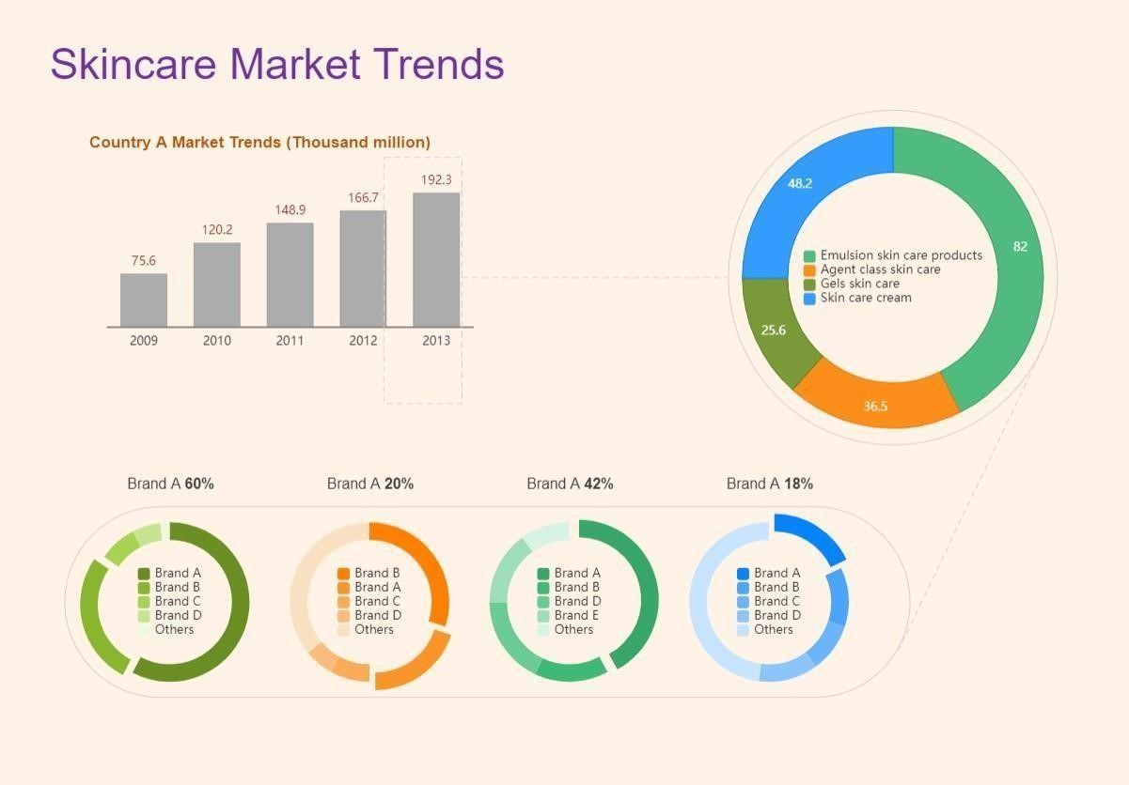

# ⬛6 Funnel Chart – Payment Method Usage

**Caption:**

This funnel chart visualizes the volume of sales through each payment method. It narrows from the most to least used method.